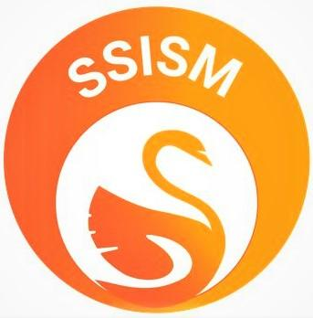
Shri Sant Singaji Educational Society
NH59/A, Gram Sandalpur, Tehsil Khategaon District Dewas (M.P.)
URL www.ssism.org,email : conact@ssism.org +91-9893371756

18/11/2020
RECRUITMENT NOTICE
(For internal and external Circulation)

WHO WE ARE
Sant Singaji Educational Society (SSES) was established in 2010, with a view to create social and economic transformation in one of the most backward areas of the country, viz. Gondwana area of Madhya Pradesh. It runs a college – Sant Singaji Institute of Science and Management in Sandalpur village, Dewas District, Madhya Pradesh. This educational institute caters to the college going youth of three rural districts of Madhya Pradesh and educates more than 1000 students annually.
Why do we need you?
We are looking for a creative Content developer that can create compelling blog posts, descriptions, social media content, web copy newsletters and articles to help us expand our digital footprint and drive more value through online content.
What we provide..
An amazing work environment that promotes personal growth through providing professional space to grow and advance your career!!Plus the opportunity to show your skills !!
Your role….
As a Content developer you will be in charge of the following:
- Implementing strategic communications plans and deliverables for SSISM.
- Creating content (written, graphic and video) for key audiences through website, Social Medias and print collaterals.
- Playing a role in advancement of SSISM newsletter, which includes creating strategies to increase open rates and signups
- Creating story ideas and new content through research, interviews with staff members and communication with students .
- Managing and updating the SSISM social media platforms and other outlets in collaboration with Impact Manager
- Identifying new trends and conducts campaigns on the organizations website, Social Medias and other outlets.
- Other activities assigned by the Impact Manager.
Up for the challenge…
Then check out our criteria:
The must haves:
- Experience in working with Microsoft Office
- Good writing and editorial skills
- Strength in storytelling
Personal qualities we are looking for:
- Creative
- Initiator
- Team player
- Good communication skills
How to Apply
Then send us your Resume/ Cv to
abison@ssism.org

